How to add a domain name to a cloud provider website

Requirements
- Have a website set up already through a cloud provider such as Microsoft Azure
- Have a domain name already purchased through a service such as GoDaddy

Part 1 – Gathering Components for Setup
- The first thing you will need to do is open up Microsoft Azure or wherever you have your webpage that you want to connect to your custom domain. This is what my dashboard looks like:
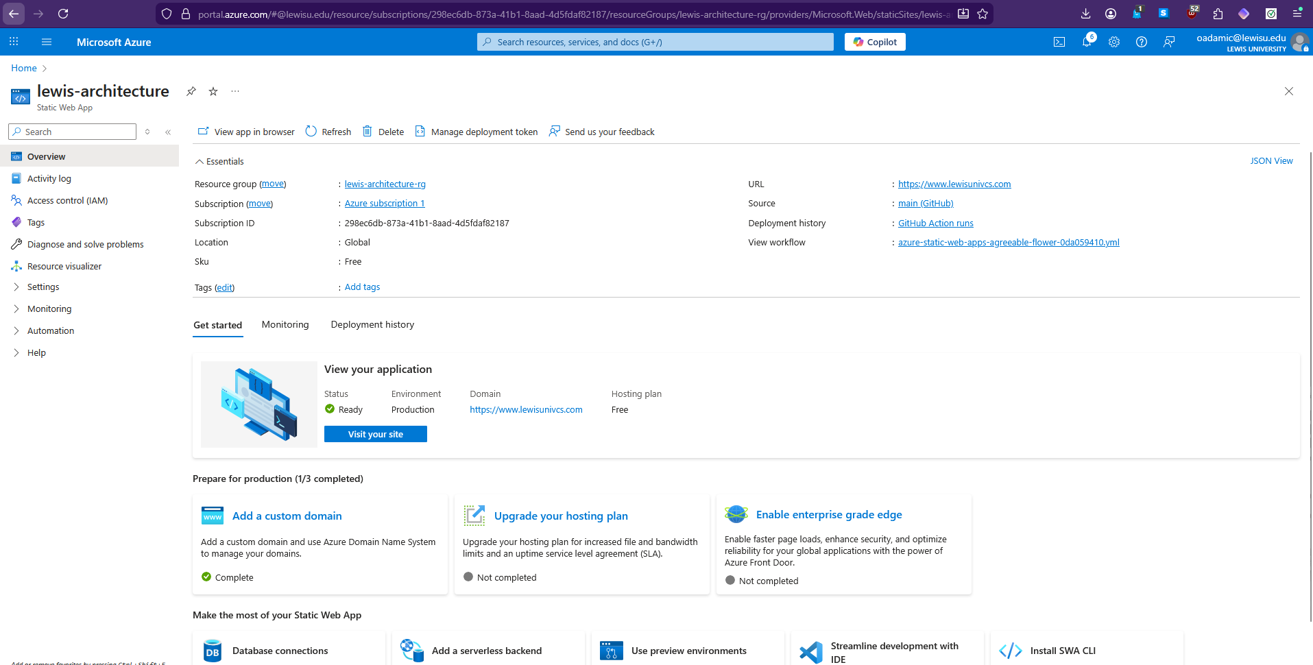
- In a separate tab, you will want to also open up your dashboard on GoDaddy or whichever site you bought your custom domain name from. Then once there, you want to click on your account profile name, then in the drop down click on My Products and then click on Domain. For this example, mine looks like this:
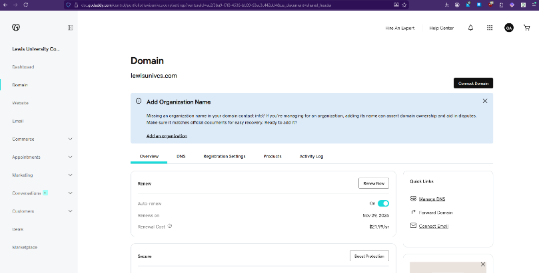

- Now, you will want to go back to Azure, and then click on the Add Custom Domain button like so (this won’t have a green checkmark near it yet on your end, mine just does because I did this setup earlier):
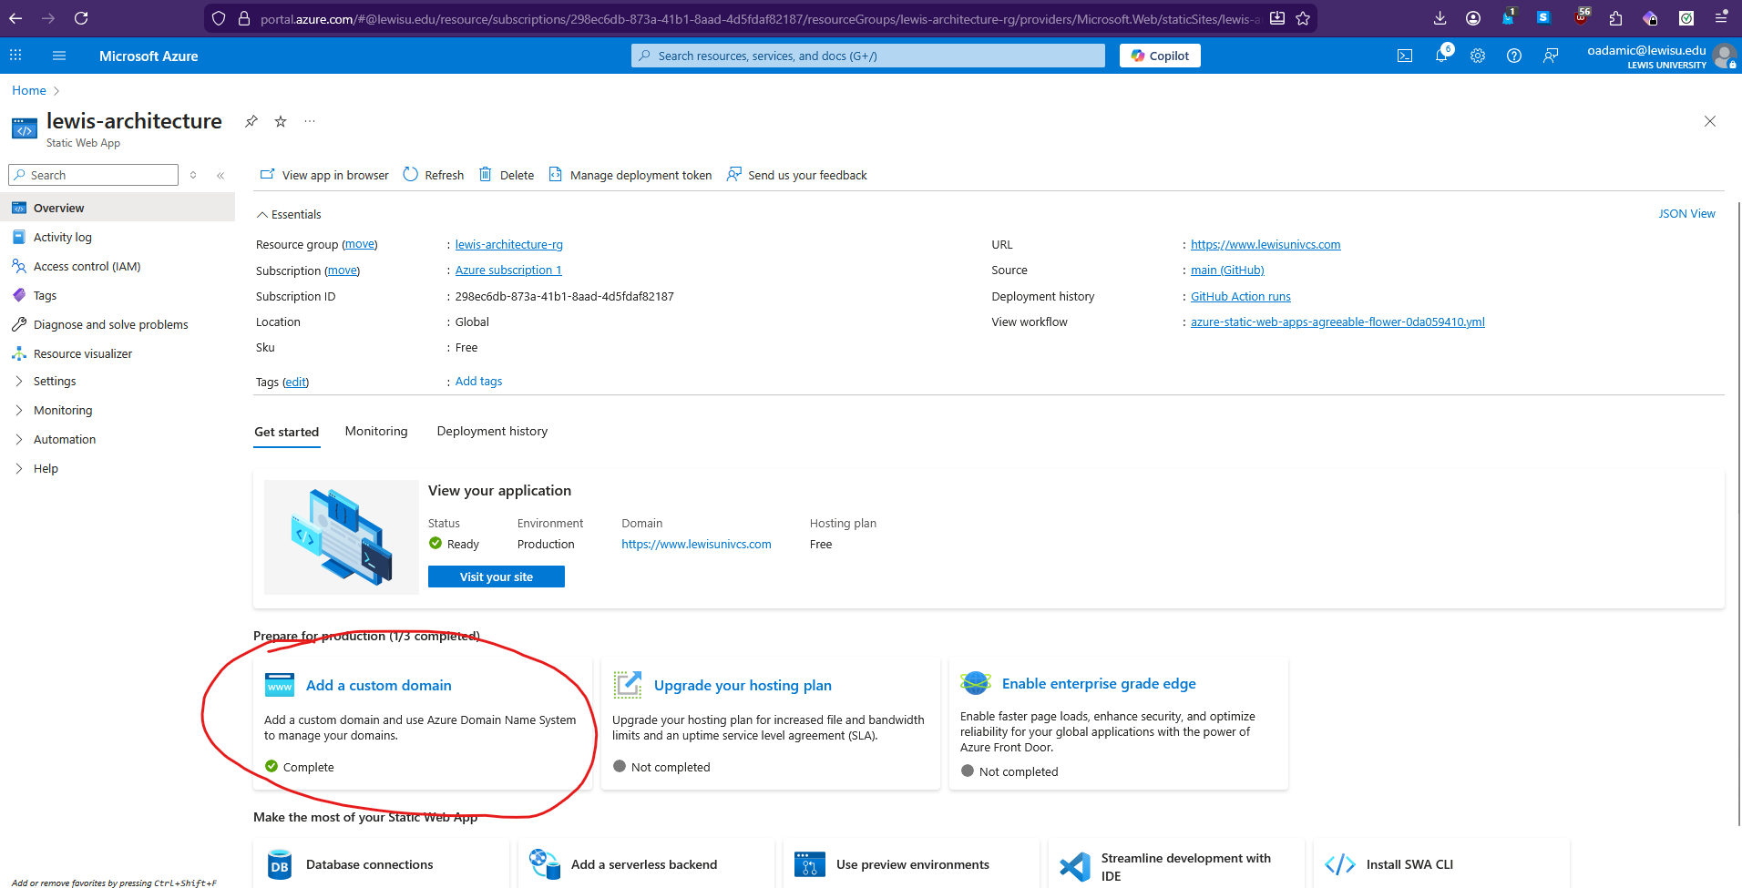
- Once on this page, you will want to click on the Add button near the top of the page and select Custom domain on other DNS from the dropdown menu. Once that is done, you will see a pop up window to your right that asks for the custom domain and DNS zone. This is where you will add in the name of your domain. The one I am adding is going to be www.lewisunivcs.com. Make sure you add the www. at the front! Once that’s done, click on the Next button.
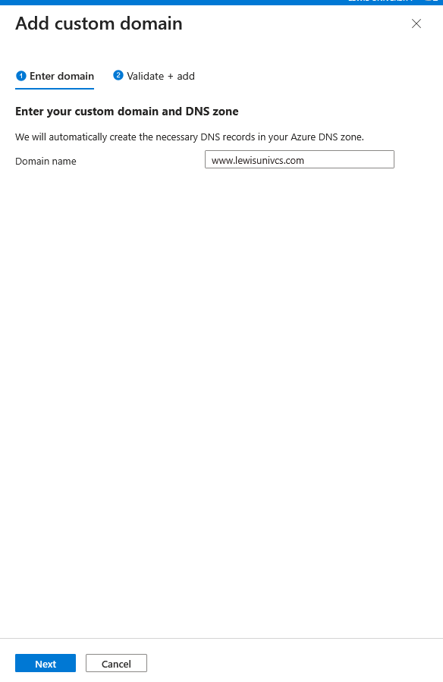
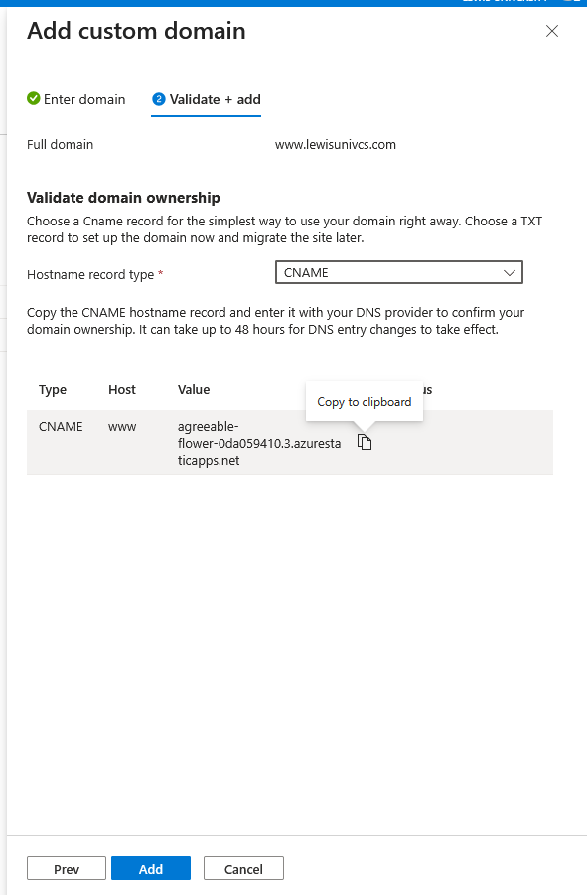
- Now, for the Hostname record type, you will want to select CNAME from the dropdown menu. You will also want to copy the value which is the current name of your cloud provider site for the next steps, but don’t click Add quite yet:

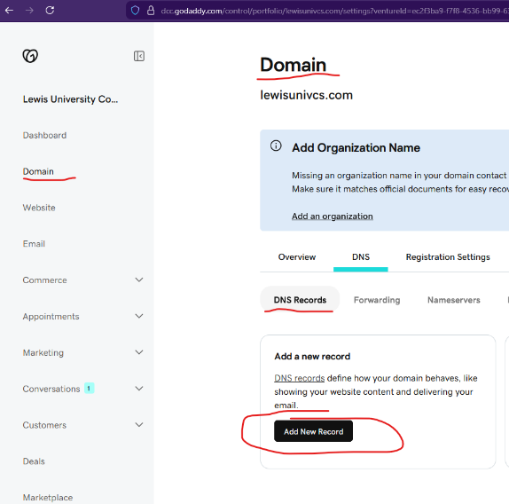
Part 2 – Configuring New Domain Name
- Now, you’ll want to switch over to your tab that has GoDaddy open. Make sure your screen says Domain at the top. Then you should be able to see an option for DNS Records and under that, there should be a button to Add New Record. Click on it, and then you should see a spot to enter the new record appear. For the Type, you want to select CNAME. For the Name, you will want to type in www and the Value should be the name of your cloud provider site without the www. included. You can leave the TTL at ½ hour as the default. The TTL or Time to Live is basically setting up how long you want the internet to remember your DNS record before refreshing it. Anything less than 1 hour is pretty good especially if you anticipate more traffic to your site. Then click Save.
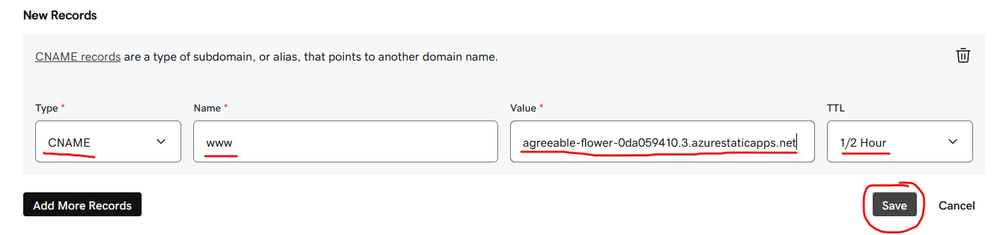
- Once it’s all saved, it should appear in the list of DNS records here:
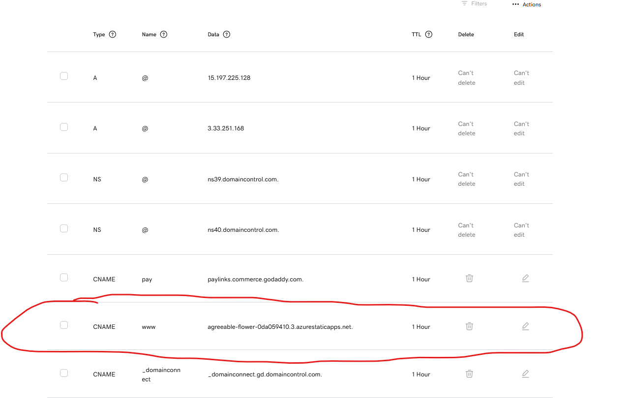
- If you’re experiencing issues with it saving and it says there’s a duplicate one or some other similar error message, that means that you need to remove the value in the list above that is your current site. You likely have a DNS record already in the list with a Name of www and the Data as lewisunivcs.com or whatever your custom domain name is. To get rid of this problem, you may need to set up domain forwarding. Go to the forwarding tab under DNS and then click Add Forwarding. You want to select the option to Forward with Masking. What this does is that when a user visits your cloud provider site, it should mask the name with your custom domain name. Make the changes and click Save:
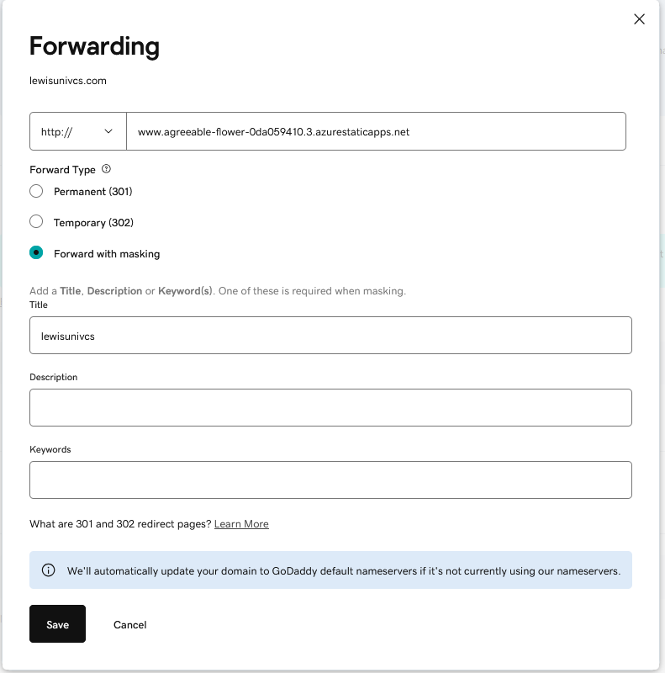

- Once that’s done, you should be able go back and complete Part 2 steps 1 and 2. Verify that your domain name is there in the list.

Part 3 – Using Cloud Provider to Connect to Custom Domain Name
- Go back to your Azure tab where you should still have that side panel open from earlier where you can see all of the components you filled in to Validate domain ownership. Now that you set up the previous components, you should be able to click on Add and then it will take a few minutes for everything to connect properly. Once it’s done successfully, you should see that your cloud provider site and your new custom domain are validated.
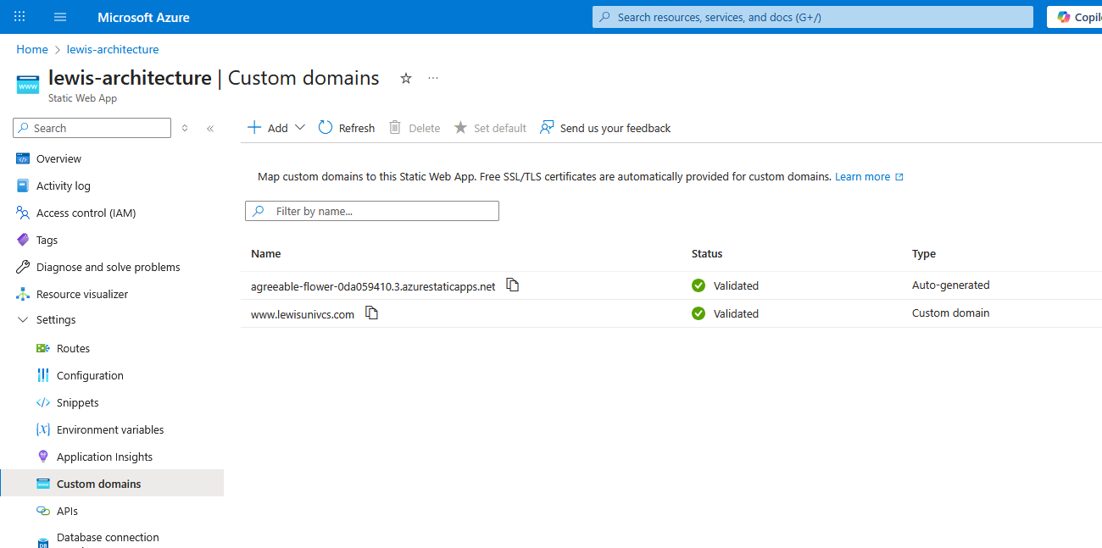

- Now for the final check, type in your custom domain in a new tab and verify that the content that was on your cloud provider site is now appearing under the custom domain name you just set up. If that is successful, then congratulations! You just added a custom domain name to your cloud provider website!

Additional Optional Steps for Subdomains
- If you want to use the same domain name to sort of separate out two projects or instructions and a project, or a portfolio resume website and a blog, well, you’re in luck because I have a few extra steps here if you’d like to do that for your site!
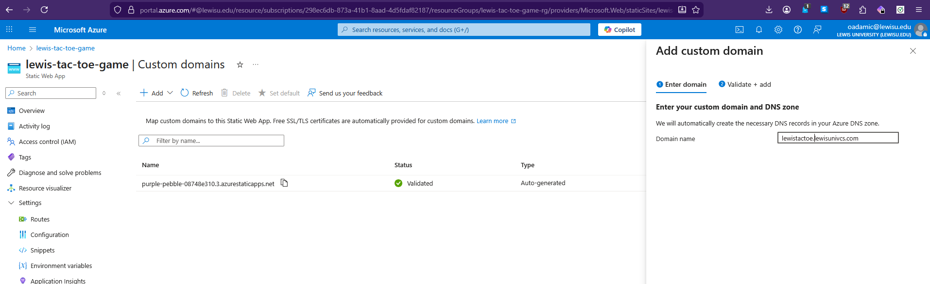
- Now, go into the Azure page for your second site. In my case, I’m making my first site as a documentation/tutorial website subdomain to complement my second project implementation site. Go through the same process to add a custom domain name in Azure for this site:

- Then choose CNAME here and then wait to add it yet:
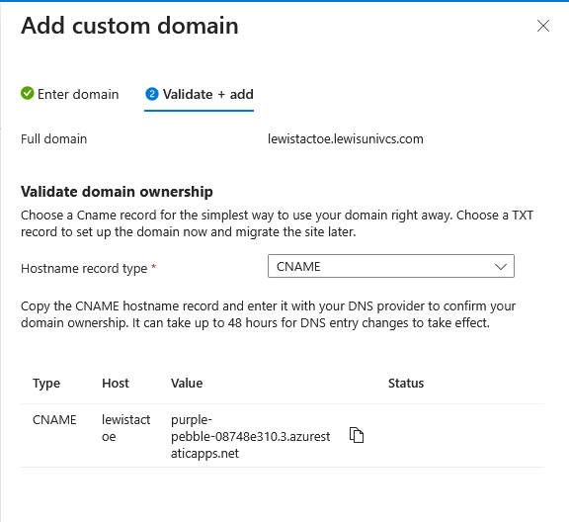
- Now go over to the Azure site for your docs or whatever other sister site you have and go make the changes there too, but you might need to delete out the previous custom domain you may already have had there first:
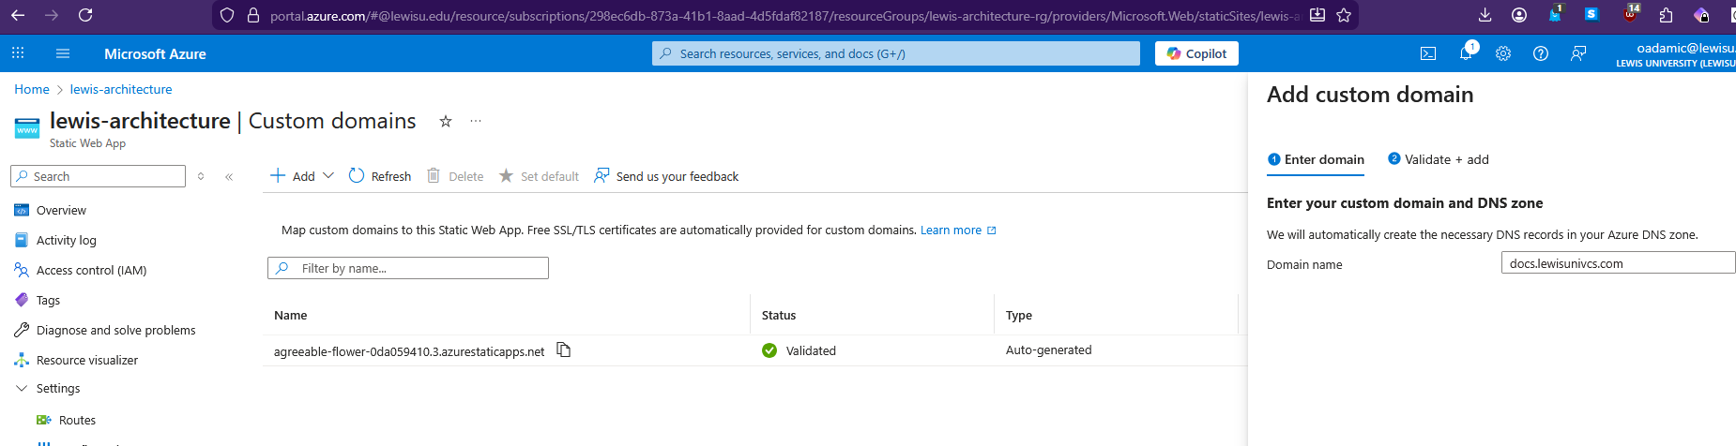
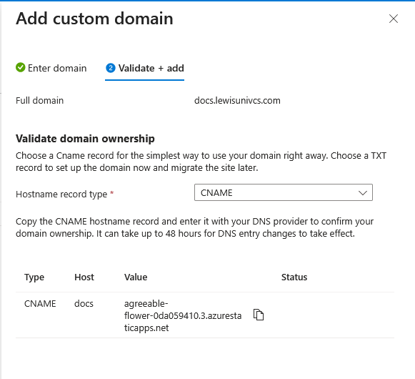
- Now what you want to do is open up GoDaddy or whichever service you use previously and then go into your products and then over to your Domain view and click Add New Record again:
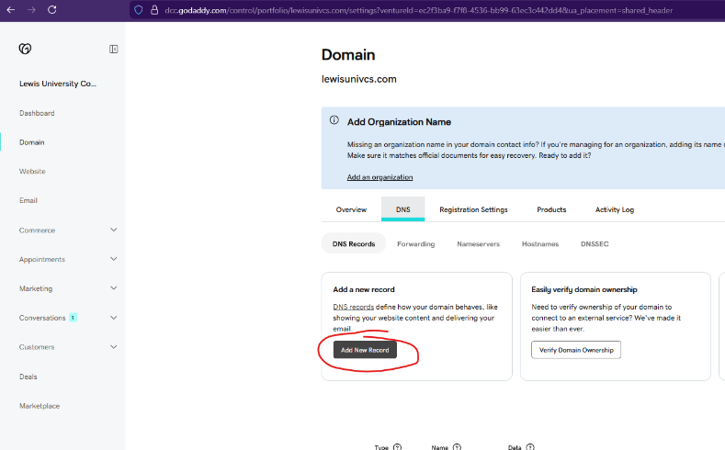

- Then you’ll follow basically the same steps as you did before to create a new record with CNAME and instead of using www for the name, you’re going to enter in the name of the subdomain you want to use and click save. But before this, if you already had a custom domain set up from the previous steps, then delete it out of the list before adding the new ones. You also may need to make some adjustments in the forwarding tab for masking if you did that for your previous site so that it doesn’t mask with the wrong site address:

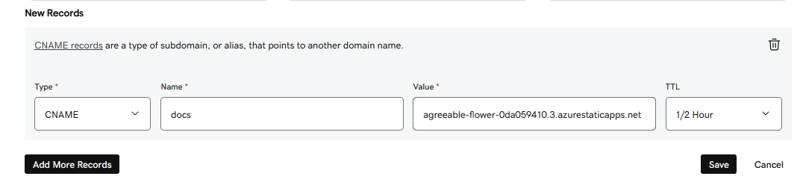
and
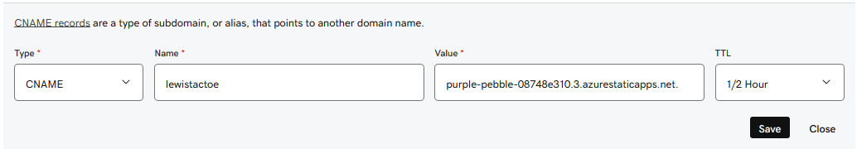

- Now go through your list of domains and verify they appear there:
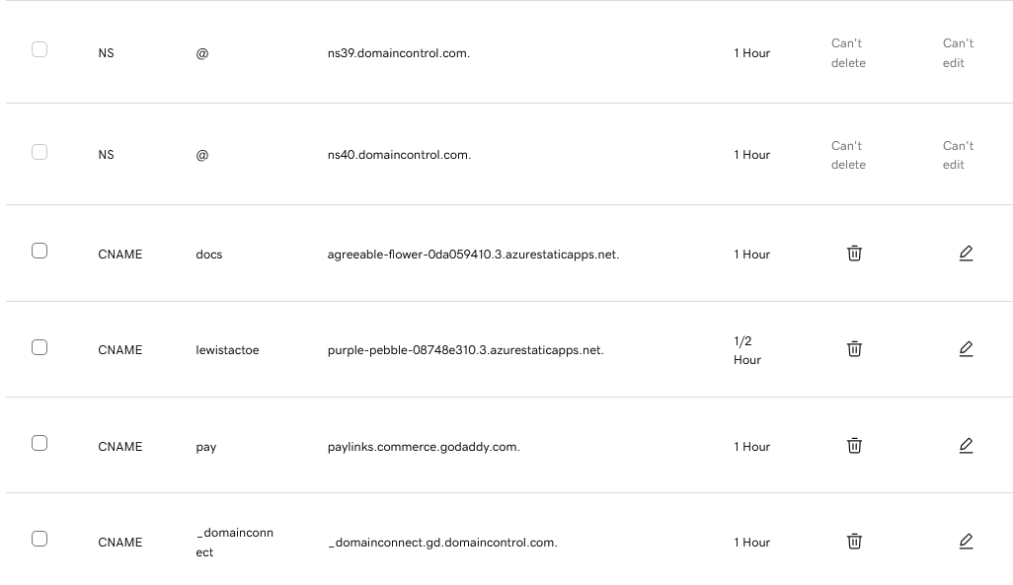
- Now, we can go back to each of our sites in Azure on the add and validate pages and then click the buttons to do so. This part might take a little while, but once you’re done, you should be able to go to each website and verify that it’s working:

Documentation/Tutorial Site 1: https://docs.lewisunivcs.com/
Project Implementation Site 2: https://lewistactoe.lewisunivcs.com/

So now you’ve successfully implemented subdomains on your custom domain site!

